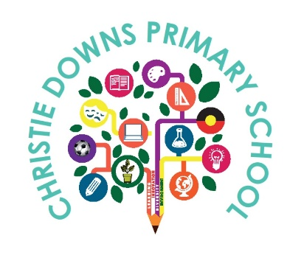

PARENT GUIDE TO RAISING A CONCERN OR COMPLAINT

At Christie Downs Primary School we are committed to delivering high quality education and care. Working with you to resolve any concerns or complaints is a key part of how we will deliver on this commitment.
It is important to work together, talk, listen and find solutions so we can improve your child’s experience and learning, and to improve our services to the community.

STAGE ONE: TALK TO THE SCHOOL
- Talk to your child’s class teacher or the Principal, Wellbeing Leader
or Senior Leaders.

  - Make an appointment or contact the school on 08 8382 3266

STAGE TWO: PARENT COMPLAINT UNIT
    - Provides advice and support

- Review complaints that have not been resolved at the school or
regional level.

  - UNIT HOTLINE: 1800 677 435

Version 3: Date: February 2023 Review: February 2024

